Chapter 5, Solution 38.

Using Fig. 5.75, design a problem to help other students better understand summing amplifiers.

Although there are many ways to work this problem, this is an example based on the same kind of problem asked in the third edition.

Problem

Calculate the output voltage due to the summing amplifier shown in Fig. 5.75.

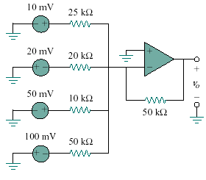
Figure 5.75

Solution

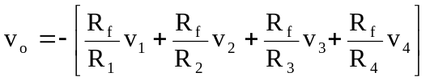
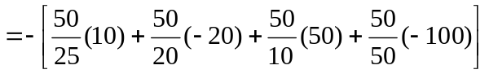

= -120mV

